**Q. How is the district summary affected?**

At school district level the overall impact on Math and English was not as significant. The percentage passing went down by around 1%.

**Q. How is the school summary affected?**

For Thomas High, the average score for both English and Math have not changed significantly. They have changed like 1%. But the passing percentage have a very big difference. Math has gone from 93.2 to 66.9 and English 97.3 to 69.6.

**Q. How does removing the ninth graders’ math and reading scores affect Thomas High School’s performance, relative to the other schools?**

In school rankings, the Thomas High school was second in ranking. After removing the 9th grade score, it was then pushed to the last rank within the district.

**Q. How does removing the ninth grade scores affect the following** –

1 Math and Reading Scores by Grade - Scores by School Spending -- There is no change in spending per student after removing the scores for 9th grader.

2 Math and Reading Scores by Grade - Scores by School Size -- For medium sized schools the average math and reading score remains the same but passing percentage drops for English from 97% to 91% and Math from 94% to 88%

3 Math and Reading Scores by Grade - Scores by School Spending -- There is no change in spending per student after removing the scores for 9th grader.

4 Math and Reading Scores by Grade - Scores by School Type-- Charter school passing percentage went down by 4% since that may be the total 9th grade students in Thomas High among all the charter schools in school district.

**Q. How is the district summary affected?**

At school district level the overall impact on Math and English was not as significant. The percentage passing went down by around 1%.

**District Summary Module**

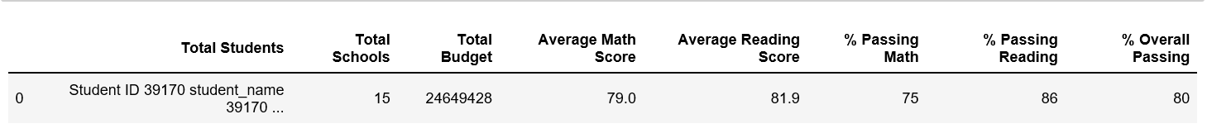

**Challenge**

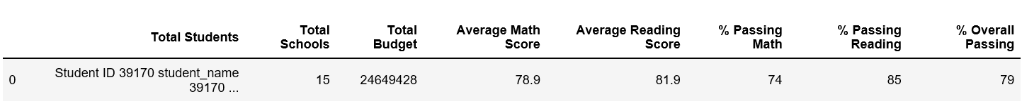

✓ How is the school summary affected? ✓ How does removing the ninth graders’ math and reading scores affect Thomas High School’s performance, relative to the other schools?

For Thomas High, the average score for both English and Math have not changed significantly. They have changed like 1%. But the passing percentage have a very big difference. Math has gone from 93.2 to 66.9 and English 97.3 to 69.6.

**School Summary Original**

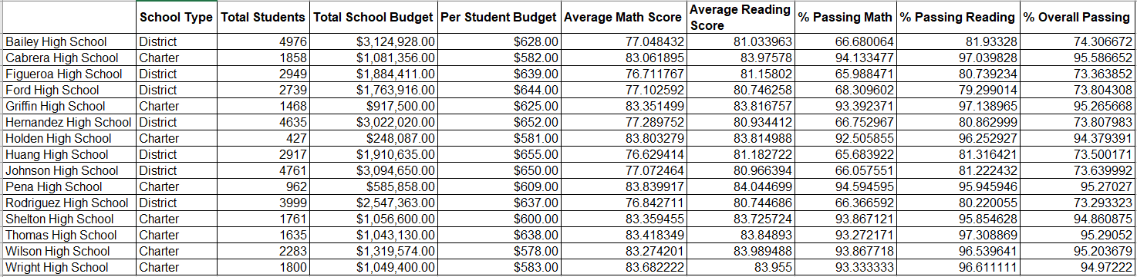

**Challenge**

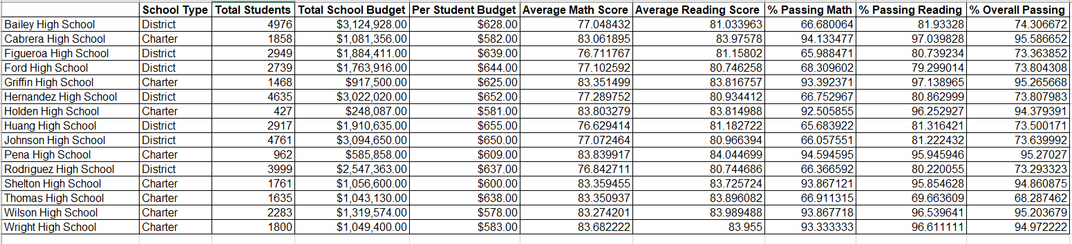

✓ How does removing the ninth graders’ math and reading scores affect Thomas High School’s performance, relative to the other schools?

In school rankings, the Thomas High school was second in ranking. After removing the 9th grade score, it was then pushed to the last rank within the district.

**Top 5 schools Module**

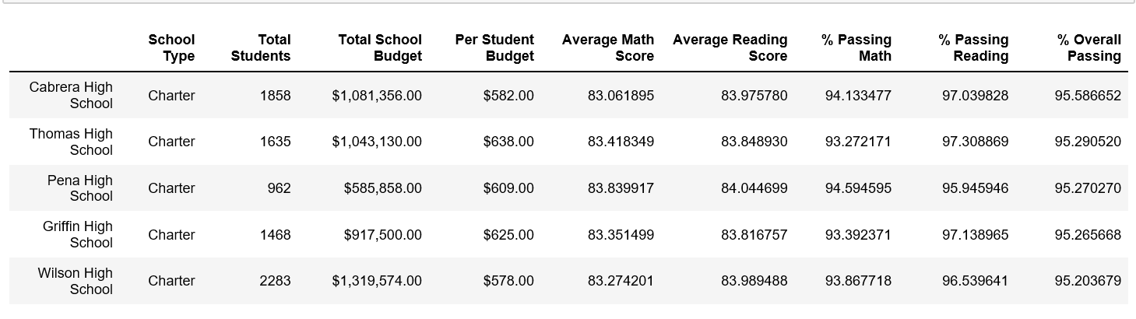

**Challenge**

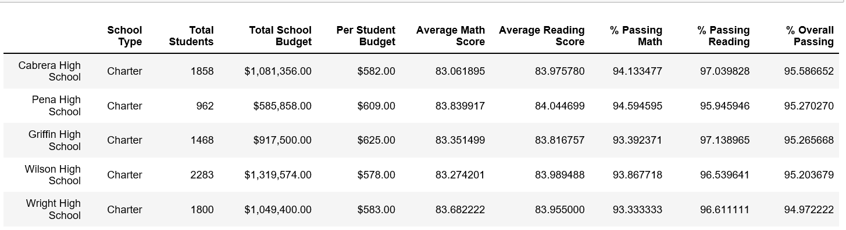

**Bottom 5 schools Module**

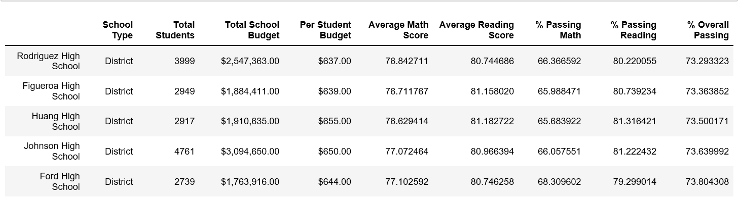

**Challenge**

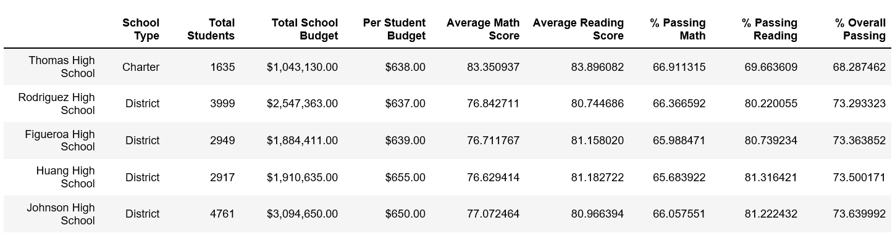

✓ How does removing the ninth grade scores affect the following –

Math and Reading Scores by Grade - Scores by School Spending

There is no change in spending per student after removing the scores for 9th grader.

**Spending Module**

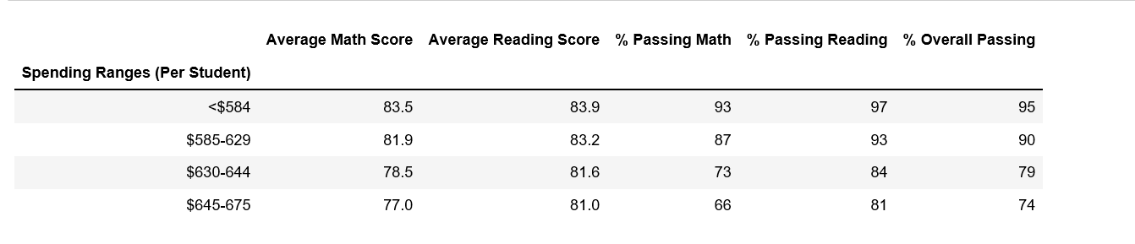

**Challenge**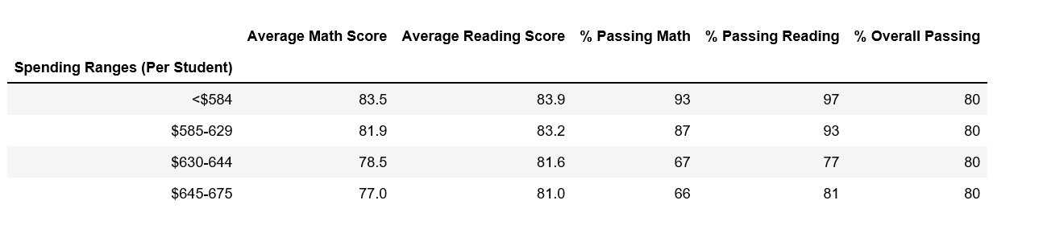

The bucket with Thomas high 630-644 shows the passing % impact

✓ How does removing the ninth grade scores affect the following –

Math and Reading Scores by Grade - Scores by School Size . For medium sized schools the average math and reading score remains the same but passing percentage drops for English from 97% to 91% and Math from 94% to 88%

**Size Module**

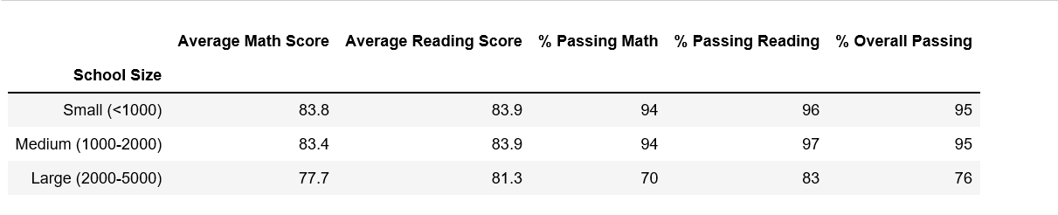

**Challenge**

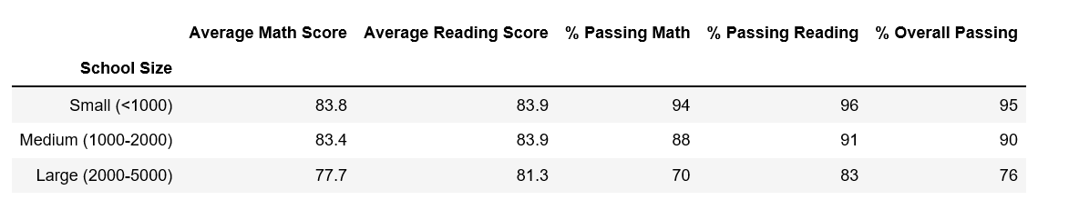

Medium size school has data change

✓ How does removing the ninth grade scores affect the following –

Math and Reading Scores by Grade - Scores by School Type. Charter school passing percentage went down by 4% since that may be the total 9th grade students in Thomas High among all the charter schools in school district.

**School Type Module**

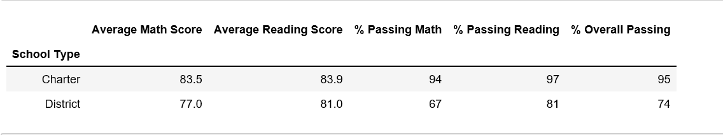

**Challenge**

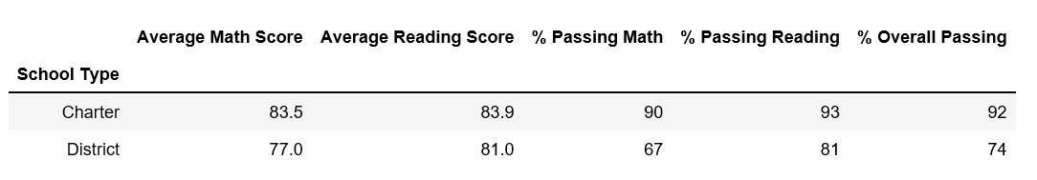

Again average passing% for Charter school went down and this is because of Thomas High school.

**Math score Module**

| **9th** | **10th** | **11th** | **12th** |
| --- | --- | --- | --- |
| Bailey High School | 77.1 | 77.0 | 77.5 | 76.5 |
| Cabrera High School | 83.1 | 83.2 | 82.8 | 83.3 |
| Figueroa High School | 76.4 | 76.5 | 76.9 | 77.2 |
| Ford High School | 77.4 | 77.7 | 76.9 | 76.2 |
| Griffin High School | 82.0 | 84.2 | 83.8 | 83.4 |
| Hernandez High School | 77.4 | 77.3 | 77.1 | 77.2 |
| Holden High School | 83.8 | 83.4 | 85.0 | 82.9 |
| Huang High School | 77.0 | 75.9 | 76.4 | 77.2 |
| Johnson High School | 77.2 | 76.7 | 77.5 | 76.9 |
| Pena High School | 83.6 | 83.4 | 84.3 | 84.1 |
| Rodriguez High School | 76.9 | 76.6 | 76.4 | 77.7 |
| Shelton High School | 83.4 | 82.9 | 83.4 | 83.8 |
| Thomas High School | 83.6 | 83.1 | 83.5 | 83.5 |
| Wilson High School | 83.1 | 83.7 | 83.2 | 83.0 |
| Wright High School | 83.3 | 84.0 | 83.8 | 83.6 |

**Challenge**

| **9th** | **10th** | **11th** | **12th** |
| --- | --- | --- | --- |
| Bailey High School | 77.1 | 77.0 | 77.5 | 76.5 |
| Cabrera High School | 83.1 | 83.2 | 82.8 | 83.3 |
| Figueroa High School | 76.4 | 76.5 | 76.9 | 77.2 |
| Ford High School | 77.4 | 77.7 | 76.9 | 76.2 |
| Griffin High School | 82.0 | 84.2 | 83.8 | 83.4 |
| Hernandez High School | 77.4 | 77.3 | 77.1 | 77.2 |
| Holden High School | 83.8 | 83.4 | 85.0 | 82.9 |
| Huang High School | 77.0 | 75.9 | 76.4 | 77.2 |
| Johnson High School | 77.2 | 76.7 | 77.5 | 76.9 |
| Pena High School | 83.6 | 83.4 | 84.3 | 84.1 |
| Rodriguez High School | 76.9 | 76.6 | 76.4 | 77.7 |
| Shelton High School | 83.4 | 82.9 | 83.4 | 83.8 |
| Thomas High School | nan | 83.1 | 83.5 | 83.5 |
| Wilson High School | 83.1 | 83.7 | 83.2 | 83.0 |
| Wright High School | 83.3 | 84.0 | 83.8 | 83.6 |

**English score**

**Module**

|  | **9th** | **10th** | **11th** | **12th** |
| --- | --- | --- | --- | --- |
| Bailey High School | 81.3 | 80.9 | 80.9 | 80.9 |
| Cabrera High School | 83.7 | 84.3 | 83.8 | 84.3 |
| Figueroa High School | 81.2 | 81.4 | 80.6 | 81.4 |
| Ford High School | 80.6 | 81.3 | 80.4 | 80.7 |
| Griffin High School | 83.4 | 83.7 | 84.3 | 84.0 |
| Hernandez High School | 80.9 | 80.7 | 81.4 | 80.9 |
| Holden High School | 83.7 | 83.3 | 83.8 | 84.7 |
| Huang High School | 81.3 | 81.5 | 81.4 | 80.3 |
| Johnson High School | 81.3 | 80.8 | 80.6 | 81.2 |
| Pena High School | 83.8 | 83.6 | 84.3 | 84.6 |
| Rodriguez High School | 81.0 | 80.6 | 80.9 | 80.4 |
| Shelton High School | 84.1 | 83.4 | 84.4 | 82.8 |
| Thomas High School | 83.7 | 84.3 | 83.6 | 83.8 |
| Wilson High School | 83.9 | 84.0 | 83.8 | 84.3 |
| Wright High School | 83.8 | 83.8 | 84.2 | 84.1 |

**Challenge**

|  | **9th** | **10th** | **11th** | **12th** |
| --- | --- | --- | --- | --- |
| Bailey High School | 81.3 | 80.9 | 80.9 | 80.9 |
| Cabrera High School | 83.7 | 84.3 | 83.8 | 84.3 |
| Figueroa High School | 81.2 | 81.4 | 80.6 | 81.4 |
| Ford High School | 80.6 | 81.3 | 80.4 | 80.7 |
| Griffin High School | 83.4 | 83.7 | 84.3 | 84.0 |
| Hernandez High School | 80.9 | 80.7 | 81.4 | 80.9 |
| Holden High School | 83.7 | 83.3 | 83.8 | 84.7 |
| Huang High School | 81.3 | 81.5 | 81.4 | 80.3 |
| Johnson High School | 81.3 | 80.8 | 80.6 | 81.2 |
| Pena High School | 83.8 | 83.6 | 84.3 | 84.6 |
| Rodriguez High School | 81.0 | 80.6 | 80.9 | 80.4 |
| Shelton High School | 84.1 | 83.4 | 84.4 | 82.8 |
| Thomas High School | nan | 84.3 | 83.6 | 83.8 |
| Wilson High School | 83.9 | 84.0 | 83.8 | 84.3 |
| Wright High School | 83.8 | 83.8 | 84.2 | 84.1 |